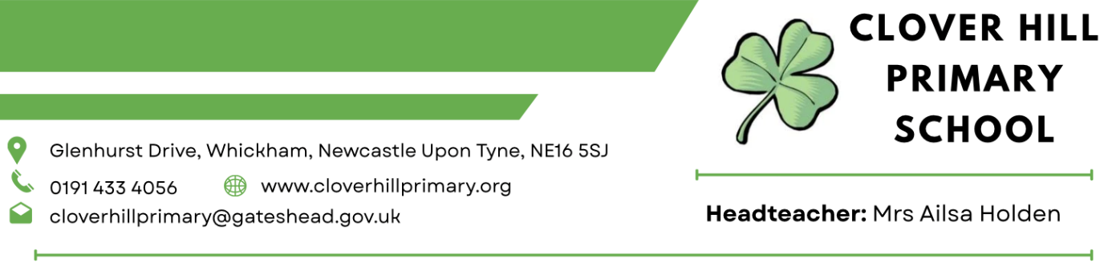

Accessibility Policy

Clover Hill Primary School

September 2025 – September 2028

Introduction and Legislative Background
Under the Equality Act 2010, all schools had the requirement to write an accessibility strategy. This was set out in Schedule 10 and specifically related to pupils with a disability. It supported the principle that ‘All children and young people who live in a school’s locality, no matter their background, circumstances or perceived ability, belonging in the local community and share the same rights to quality education in their local neighbourhood school’.
The Equality Act 2010 replaced all previous equality legislation including the Disability Discrimination Act and set out the legal obligations for schools and other educational settings have towards disabled children and young people. The effect of the law is the same as previous, meaning that schools must not directly or indirectly discriminate against, harass or victimise disabled children and young people. In addition, they must make reasonable adjustments, including the provision of auxiliary aids and services, to ensure that disabled children and young people are not at a substantial disadvantage compared to their non-disabled peers. The duty is anticipatory- it requires thought to be given in advance to what disabled children might require and what adjustments might need to make to prevent that disadvantage.
According to the Equality Act 2010, a person has a disability if:
- He or she has a physical or mental impairment or
- The impairment has a substantial and long-term adverse effect on his or her ability to carry out normal day-to-day activities.
Physical and mental impairment can include sensory impairments (such as those affecting sight and hearing) and learning difficulties. The definition also covers certain medical conditions when they have a ‘long term’ or ‘substantial’ effect on their ability to undertake normal day to day activities.
According to the Special Educational Needs and Disabilities (SEND) Code of Practice (2015) ‘long term’ is defined as ‘a year or more’ and substantial is defined as ‘more than minor or trivial’. This definition includes sensory impairments such as those effecting sight and hearing, and long-term health conditions such as asthma, diabetes, epilepsy and cancer.
Aims and Objectives
At Clover Hill Primary School, we support Gateshead Local Education Authority’s vision that all children and young people should have an inclusive education. As an organisation, Clover Hill aims:
‘To provide a broad and balanced curriculum in a happy, challenging environment where each pupil can develop to the maximum of his/her potential and feel valued as an individual who can contribute to the life of our school and society in general.’
To achieve this mission statement, we promote:
- Pupil self confidence so that each pupil develops a sense of personal worth and is confident in his/her ability to succeed.
- Positive relationships to help pupils develop good relations with others, based on mutual respect and consideration, and an understanding of, and tolerance towards various races, religions and cultures.
- Co-operation to develop the abilities of pupils to contribute as members of groups and recognising their responsibilities.
- Self-discipline so that pupils understand the need for high standards of behaviour and to develop responsibility towards people and property.
As an educational institution, we work closely with disabled children, their families and any relevant outside agencies in order to remove or minimise any potential school barriers to learning so that all children can learn, achieve and participate fully in school life. We will make reasonable adjustments to ensure that a child or member of staff with disabilities is not placed at a disadvantage.
Whole school training will continue to raise awareness of equality issues for staff and governors, to comply with the Equality Act 2010.
Our Accessibility Plan
At Clover Hill Primary School, our Accessibility Plan shows how access is to be improved for disabled children, staff and visitors to the school within a given time frame and anticipating the need to make reasonable adjustments to accommodate their needs where practicable.
The Accessibility Plan contains relevant and timely actions to:-
- Ensure the school curriculum meets the needs of pupils with SEND and disabilities.
- Ensure school leaders and governors evaluate and address the physical environment of our school to make improvements for disabled pupils.
- Ensure schools produce accessibility action plans.
- To improve the delivery of written information to children, staff, parents, and visitors with disabilities.
- Provide training and resources to help develop school staff awareness of how they can improve their delivery for SEN and disabled pupils.
- Work with health and social care in supporting accessibility in schools.
The accessibility plan for physical accessibility relates to the Access Audit of the School. It may not be feasible to undertake all of the works during the life of this accessibility plan and therefore some items will roll forward into subsequent plans. An accessibility audit will be completed prior to the end of each period covering this plan in order to inform the development of a new Accessibility Plan for the ongoing period.

Access Audit
- The school is a CLASP (Consortium of Local Authorities Special Programme) building typical of those built during the 1950s until the 1980s.
- The school exists entirely on one floor with a ramp leading to the main entrance.
- Our on-site car parking for staff and visitors includes a dedicated disabled parking bay.
- In the outside area, the school has contrast edging with dual height rails on stairs and steps where required.
- The school has accessible break areas and an accessible dining area with appropriate tables.
- The school has a private room to allow for the administration of medication if required.
- The school has a disabled toilet available next to the main entrance to the building. This toilet is fitted with a handrail and emergency cord.
- The school has an induction loop for hearing aid users.
- The school has internal emergency signage and escape routes are clearly marked.
When needed, a risk assessment will be carried out and personal evacuation plan will be drawn up for any pupil with a physical disability. All staff working with the student will be made aware of this plan.

Monitoring Arrangements
This document will be reviewed by Governors and the Head Teacher every three years, however it may be updated more frequently if necessary.

Links with other policies (All Policies can be found on the Clover Hill Website)
- Health and Safety Policy
- Equality Policy and Statement
- SEND Information Report
- SEND Policy
- Safeguarding Policy
- Pupil Premium Strategy Statement
- All Curriculum Policies

