Dear Parent/Carer
Gateshead School Catering deliver the School Meals at your child’s school. We are Gateshead Councils in house catering service, with over 320 members of staff who provide over 10,000 meals per day across 72 sites.
We are passionate about providing children with the best fuel for the school day. Our school meals offer value for money, and our menus a range of fresh ingredients, often from local suppliers, served by a skilled and experienced team. School meals offer children the chance to eat a nutritious, tasty meal in a sociable, safe environment.
Your child can choose from two main meal options provided every day, one of which is a vegetarian dish, alternatively they can have a jacket potato served with a tasty filling (some schools also operate a deli selection).
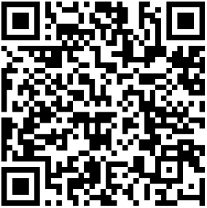
Our menus for each school are available on our website, to view your child’s school meals options, you can use the QR code below.

We strive to ensure pupils of Gateshead can enjoy the nutritious and delicious school lunch on offer regardless of any allergies, intolerances, medical or alternative diets. We recognise medical diets as an extremely important aspect of our catering provision, aiming for all pupils to enjoy their lunch time experience, without the worry of being singled out. If your child has a medical or alternative diet, please contact your child’s school or email SchoolCatering@Gateshead.Gov.UK and you will be provided with a form to complete so we can investigate options for them.
Did you know pupils in reception class, year 1 and year 2 who attend a government funded school are entitled to a free school meal through the universal infant free school meal (UIFSM) scheme?
Children may also be entitled to a free school meal if parents receive certain welfare benefits. For every valid application for free school meals, not only will your child receive a healthy, nutritious meal, the school will be able to claim additional funding which can really help provide the best environment to support your child’s learning and development. To find out if you qualify contact the free school meals team on 0191 433 3729 or by email benefitsfsm@gateshead.gov.uk.
To find out more about school meals, please visit www.gateshead.gov.uk/schoolmeals or ring the Catering & Cleaning office on 0191 433 5522.
Yours sincerely,
Gateshead School Catering

