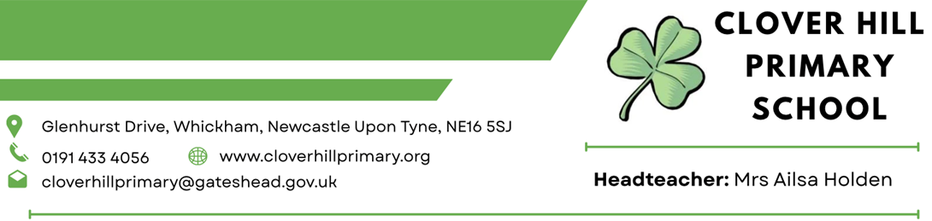

Collection of School Meals Money and School Meals Debt Policy

2025-2026

The Governing Body of Clover Hill Primary School adopted this Policy

June 2021 and it will be reviewed annually

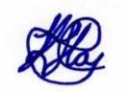
Signed Kevin Hay (Chair)

11/09/25

Clover Hill Primary School
Collection of School Meals Money and School Meals Debt Policy

The Clover Hill Primary School meals collection and debt policy has been adopted to ensure that a fair and consistent approach is taken to debt incurred by parents / carers whose children take school meals.

General Principle
School meals must be paid for prior to the meal being taken, preferably on a Monday for the week ahead or in exceptional circumstances on the day the meal is taken.

Free School Meal Entitlement
If parents / carers believe their child(ren) may qualify for free school meals they should contact Gateshead Council on 0191 4333729, e-mail benefitsfsm@gateshead.gov.uk or ask for an application form from the school office. The school is only allowed to provide a free meal where this is officially approved by the local authority.

Cost of School Meals
There is no charge for children in Years Reception, Year 1 and Year 2 and they can have a free school meal from the Governments Universal Infant Free School Meals initiative.
School meals are available to children in years 3-6 at a cost of £3.00 per day with no cost to those in receipt of free school meals entitlement. Any revision to school meals prices will be notified to parents/carers the term prior to the new charge taking effect.

Payment for School Meals
School meals must be paid for in advance of meals being taken. All payments are made online through our new MIS system called Arbor which can be accessed. Meals may be paid for on a daily, weekly, half termly or termly basis.
When parents/carers log onto Arbor they can easily see the balance of their account.

Non-Payment
We understand that there are times when parents may forget to make payment.
Where a child continues to take meals which have not been paid for, the school will contact the parent daily detailing the amount of money owed. The school will also contact the parent / carer to ask if they are experiencing hardship which is affecting their ability to pay. Under these circumstances the parent / carer should be invited to apply for free school meals and / or speak confidentially to the Head Teacher.
If the debt continues to accrue, contact must be made with the parent / carer informing them to provide a packed lunch until the arrears are cleared.
If the school are unsuccessful in securing the dinner money arrears, the school should advise the local safeguarding team and formally write to the parent / carer, explaining that the school is not obliged to provide a school dinner where advance payment is not forthcoming or where authorisation for free school meals has not been received. (see letter)

Monitoring and Recovery of School Meal Debts
At each Governing body finance meeting, the Head Teacher will provide the Governing body with details of any outstanding dinner money debt and the current position with regard to such debt. The aim of this policy is to minimize the opportunity for debt balances to build up. The school reserves the right to begin proceedings to recover outstanding school meals debts and inform the local authority that a child is not being provided with a suitable meal at lunch time. All write-offs of outstanding debt must be approved by the governing body / finance committee by the Head Teacher with reasons for no further action being taken.

Letter

Date

Parent / Carer of
Address
Post Code

Dear
Re: School Meal Payment for XXXXXX

XXXX has been taking school meals this term, but the school has not received any dinner money recently. The outstanding balance on xxxxx was –£xxxx.

I ask that you please make arrangements to clear this debt immediately and take steps that no further debt accrues.

If you think you qualify for free school meals, please contact the school office for an application form or contact Gateshead Council on 0191 4333729.

Until the arrears have been cleared, I ask that you make your own arrangements for their lunch.

If you have any queries, please contact the school office immediately so this can be resolved.

Yours sincerely

Head Teacher

