
Year 6 2026-27
Autumn Term Information for Parents
Dear Parents/Carers
The final year for your children at Clover Hill Primary School begins! I feel very lucky to be teaching this wonderful group of children for a second time and being part of the start and end of their Clover Hill journey! Year 6 is about learning those essential academic skills to equip our children for their future learning when they move on from Clover Hill.
I will be teaching the children each day with the exception of a Thursday morning (when Mrs. Holden will be teaching) and a Tuesday afternoon when Miss Sinclair, our Year 6 Teaching Assistant, will be teaching Art and PE.
We are really looking forward to be working with these super children. Most importantly, we are looking forward to guiding the children through this last exciting and challenging chapter of their education at Clover Hill. We’re sure they will embrace these challenges, responsibilities and privileges of being the oldest children in our school.
SATs
All Year 6 children will complete their SATs in the week beginning Monday 10th May 2027. We will be sending out more information must nearer the time but for now, please make a note of the date so that you can do all you can to ensure that your child is present at this time.
Please do not hesitate to get in touch should you ever have any questions or concerns regarding your child. I will be at the Key stage Two door at home time if you need to catch me with a quick message or query. Alternatively, please use the year6@cloverhill.school email address but be aware that it is not monitored throughout the day and it may take up to 48 hours to receive a response. For this reason, contacting the school office for urgent messages or those concerning attendance etc will be the best option.
Mrs. Farnaby – Year 6 Teacher
Miss. Sinclair – Year 6 Teaching Assistant
Year 6 Autumn Term Curriculum:
In English this term, our work will be based around three main class texts: Beowulf by Michael Morpurgo, Wild Boy by Rob Lloyd Jones and Holes by Louis Sachar- reading and writing will be linked to these texts. Spelling, grammar and punctuation are taught as discrete lessons and also incorporated into the reading and writing sessions.  As always, there will be a drive to ensure basic skills are embedded in every piece of work.  In Maths, we will be concentrating on numbers and the number system, place value, calculations using the four operations and fractions. We will also be introducing ‘recap and revisit’ sessions every day to consolidate previous learning and embed skills in the children’s long-term memory. There will be an emphasis in every lesson on practising the skills taught (fluency) followed by problem solving and reasoning.  However, we cannot stress the importance that your child knows their multiplication facts up to 12 x 12. In Year 6, the pace is fast, there is a lot to get through and we do not have time to go back and teach times tables that should have been embedded by the end of Year 4. We would appreciate your support in helping your child to consolidate and reinforce the instant recall of tables facts. They will need these across most areas of Maths and without them they will struggle so I will set up all children who are not confident with their tables their own TTRS challenge. Please support this at home by encouraging them go practice for 10 minutes per day. | - History – The Victorians  - Science – Inheritance and Evolution Electricity  - Art – William Morris – block printing, watercolours  - Design and Technology - Bridges  - Computing – Internet safety Networks Web Design  - RE – Christianity  - PE – Tag Rugby, Netball, Health Related Exercise, Gymnastics  - French – Pets, At Home, Going to School, In the Classroom  - Geography – Economic Activity of the UK  - PSHCE – Assertiveness Cooperation Safe/unsafe touches Positive relationships  Music – Sing, play, perform: accompanying songs with polyrhythms

Year 6 Routines
PE | Monday and Tuesday
Homework | We will set homework each Friday and ask that it be completed by the following Friday.  - Maths - Arithmetic Booklet. This will form the basis of our maths homework and a page will be set from it each week. Any child not secure in their times table knowledge will also be a set a personalised challenge linked to Times Tables Rock Stars  - Reading – 3 times per week and marked up in yellow book.  - Comprehension – one reading comprehension activity per week.  - Spelling -assignment set on Spelling Shed and a specific spelling pattern to learn
Library visit | We visit the school library each Thursday afternoon so your child has the opportunity to choose their own book to read for pleasure. Please ensure library books are returned each Wednesday so that they can be exchanged regularly.
Spellings | Every Friday (New word lists given on Mondays). A weekly spelling test will also take place every Friday based on the list of spelling words set each week, as well as an online assignment set on Spelling Shed. Please encourage your child to spend time not only learning how to spell these words but understanding the meaning of the words to be able to use and apply the spelling pattern in their independent writing.
Anyone not completing their homework will be expected to complete it during school to ensure that they do not fall behind their peers and that they get into good working habits ready for their next school. As a working mum with a busy home life, I fully appreciate that it is sometimes really difficult to get homework done and that there are occasions where you may go away for the weekend or have visitors staying etc meaning that tasks are not done or submitted late. This is absolutely fine – just let me know or ask your child to mention it to me in class and I will do my best to ensure they are given time to complete work.

Routines
As experienced teachers (and parents ourselves), we are aware of the importance of structure and a predictable routine for children; it enables them to feel secure and confident in their environment. We want all of our children to be happy, confident and to thrive in our care and we realise that, for some children, a familiar pattern to the day is extremely important in maintaining their wellbeing and alleviating any feelings of worry or anxiety. For this reason, we display a visual timetable in class so that children know what is going to happen next. The nature of primary school day means that we do occasionally change our routine to accommodate special events or visitors and these changes are always explained to the children in advance.
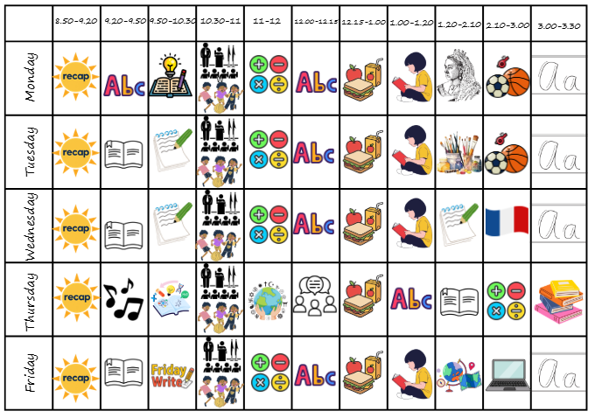
Useful to know…
Each day, your child should bring a water bottle to school and they also have the option of bringing a healthy snack for break times consisting of either a piece of fruit or a cereal bar. Due to allergies, please remember we are an allergy aware school and operate a ‘NO NUTS’ policy and no products containing nuts should be brought into school.

Also, as the colder months approach, any donations of boxes of tissues for the class would be very much appreciated!

Throughout the year, we will use Class Dojo regularly to send general class reminders, messages or achievements so please ensure you have the app downloaded and correct log in details so that you receive this information.

We have a number of exciting visits and experiences in the pipeline across the year – dates and more information will follow nearer the time.
- Beamish Museum or Tanfield Railway
- Safety Works
- Weardale Activity Centre (2 nights)
- Various transitions visits to Whickham School.

