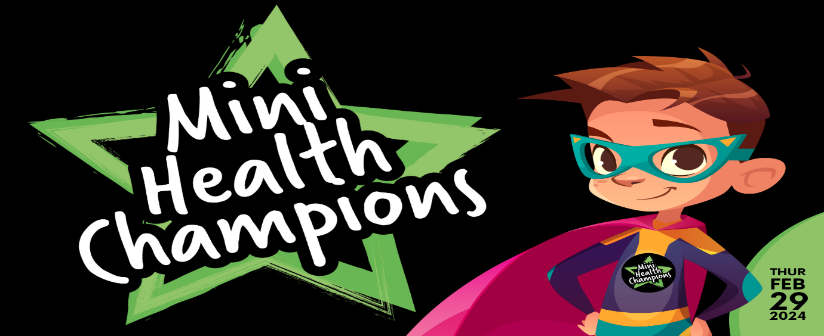
Clover Hill Mini Health & Wellbeing Champions: Action Plan March 24
School of Kindness
Being Kind is a real superpower. Kindness costs nothing. Kindness is contagious - it spreads and catches on. Kindness brings us together.
Qualities: Friendly, Generous, Considerate, Empathy
Kindness Health Benefits: Healthier hearts, Slows down ageing, Helps you feel happier.
Ideas: Set up a kindness day, Create a kindness tree to hang kind messages on.

Be the change you want to see in the world.
Make the difference – YOU, not someone else.

Road Safety
Junior Road Safety Officers message to share: Stop - Look - Listen - Think
Don’t park in dangerous places - be considerate and sensible.
Encourage: Park and Stride.

Climate and Environment
The greatest threat to our planet is the belief that someone else will save it.
No one is too small to make a difference.
One SMALL step can add up to make a BIG difference.

North East Ambulance Service
Important to know the phone numbers 111 and 999.
Know your address and postcode and family phone numbers.

Physical Activity
Children need to do 1-hour active exercise every day as well as normal PE lesson.
Active ideas: Lap of the school playground before you enter the building on a morning.
In class- Wake-up Shake up activities, Keep fit DVDs Jump Start Jonny
Answering Qs in lessons actively = Star jump for YES and jogging on the spot for NO

